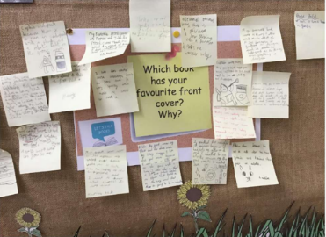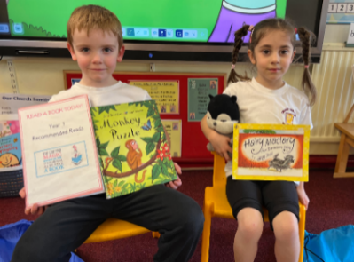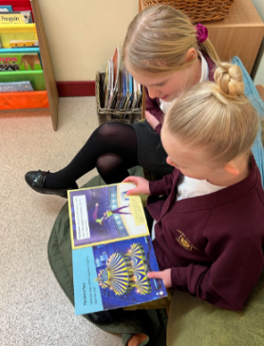

**Reading Ambassadors and Buddies**

Weekly morning reading slots with years 1 and 2

Planning of whole school reading events

Book recommendations

Book bench – lunchtime club for children to read independently or with a reading buddie/ambassador.

**Recommended Reads**

* Recommended reads journals
* Teacher recommended reads display
* Weekly Book talk question for children to discuss and share books.

Reading for Pleasure at CtK

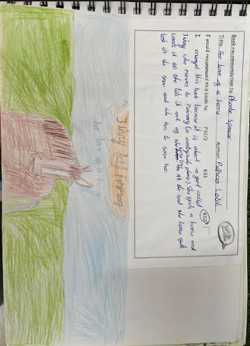

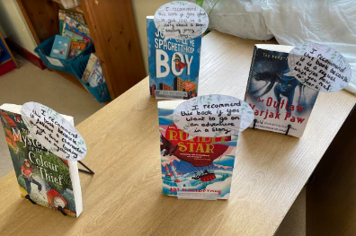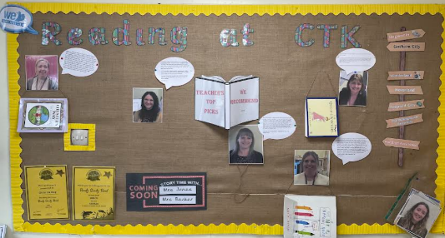

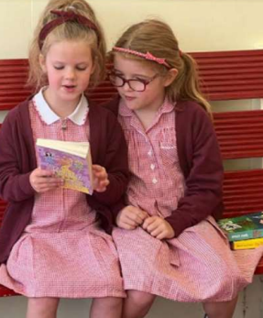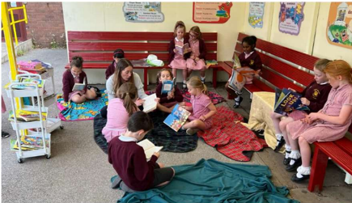

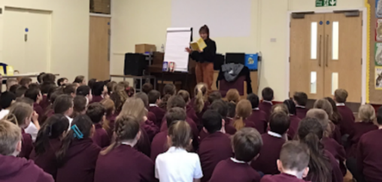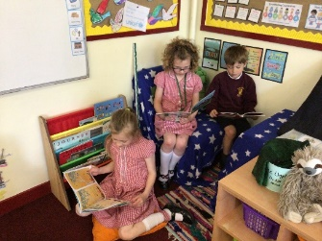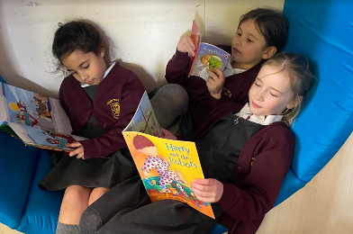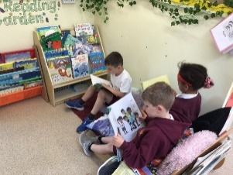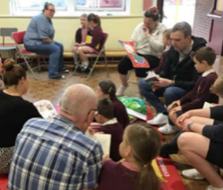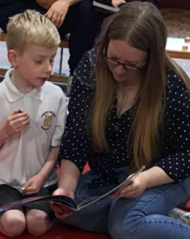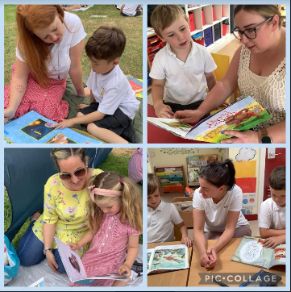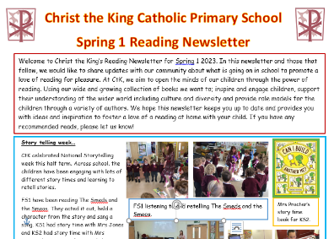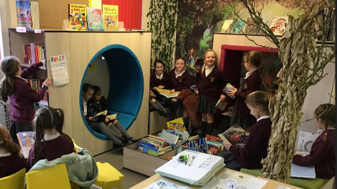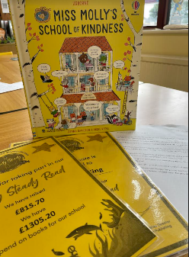 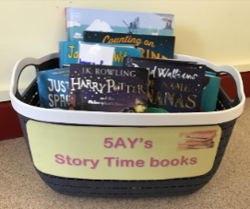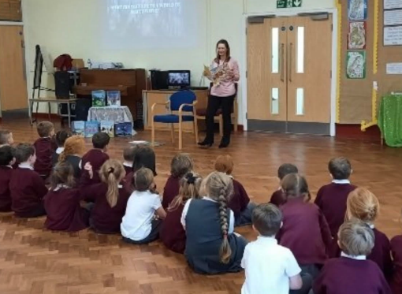

**Whole school**

* Author visits
* Author of the month
* Book club – book talk in classes.
* Story time with SLT
* Mystery reader – staff
* Whole school library open for all year groups
* Book swap shop – children swap a book, which they have read, from home with another child.
* Sponsored Read
* Story time book boxes for daily story time
* Classroom reading corners with books chosen by teachers and pupils.
* Year group and class swaps to share books and read stories.

**Parental involvement**

Reading cafes

Mystery reader visitor in FS2 and Year 1

Half-termly reading newsletters

Stay and Read